**Blog about windows and document object**

**Window:**

* **The window is the first thing that gets loaded into the browser**
* **This window object has the majority of the properties like length,innerheight,name,open,close,moveTo,resize etc.,**
* **Window is the global object**

**Image of the window without document object**

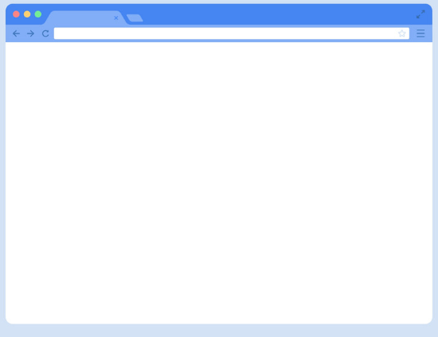

**The document:**

* **The document object is html,aspx,php or other document that will be loaded into the browser**
* **The document actually gets loaded inside the window object and window object and has properties available to it like title,URL,cookies and all properties related to DOM**

**The image of document object loaded into the window object**

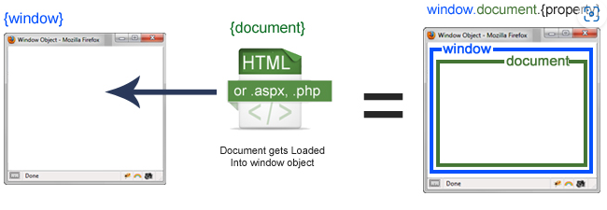

**Difference:**

|  |  |  |
| --- | --- | --- |
| **S.no** | **Document object** | **Window object** |
| 1 | It represents the html document or any other doument | It represents a browser window |
| 2 | It is loaded inside the window | It is the very first object loaded inside the browser |
| 3 | It is object of window property | It is the object of browser |
| 4 | We can access the document from a window using the  window.document | We can access the window from the window only .  i.e window.window |
| 5 | The document is part of (browser and window object model) | Window is browser object model |
| 6 | Syntax:  document.propertyname | Syntax:  window.propertyname |
| 7 | Example:  window.document.tilte  Or  document.title  Will return the title of the document | Example:  window.open  window.close  window.moveTo |